# Article search:

[Human & Posture & Tracking](https://pubmed.ncbi.nlm.nih.gov/?term=%28%28human%29+AND+%28posture%29%29+AND+%28tracking%29&filter=years.1981-2024)

## Meta Review

### Clinical Applications of Sensors for Human Posture and Movement Analysis

Ældre artikel fra 2007, som reviewer artikler fra 1990’erne. Her fremlægger de 5 alternative løsninger til video-basseret positionering tracking. Accelerometer, gyroskope, Flexsible angle sensor (Strain gains), Elektromagnetisk tracking sensor og sensing fabric. De konkludere at Accelerometer er mest brugt, da det både kan bruges dynamisk og static da det kan tage højde for tyngdeaccelerationen

Brugt til benposition ved montering på Thigh and Shank  
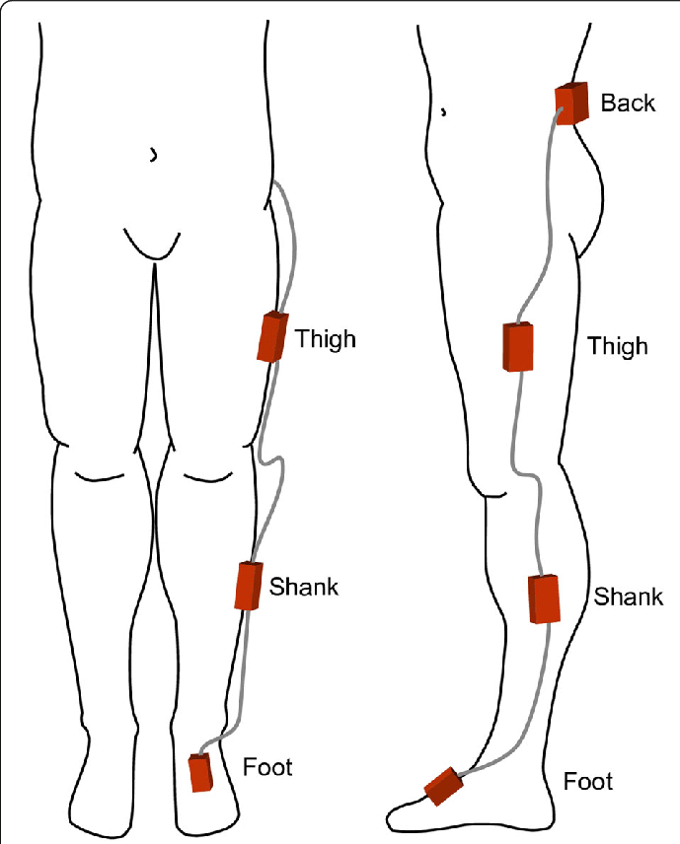

Van Someren (1996)

Van Someren EJW. 1996. Actigraphic monitoring of movement and rest-activity rhythms in aging, Alzheimer’s disease and Parkinson’s disease. In: 18th Annual International Conference of the IEEE Engineering in Medicine and Biology Society. pp 69–70.

Veltink PH, Olde Engberink EG, van Hilten BJ, Dunnewold R, Jacobi C. 1997. Towards a new method for kinematic quantification of bradykinesia in patients with Parkinson’s disease using triaxial accelometry. In: Proceedings of 17th Annual International Conference of the IEEE Engineering in Medicine and Biology Society. pp 1303-1304.   
*** Disse burger optical hand tracking system (Leap Motion Controlle)***

## Acc and Gyro

### Automatic Posture and Movement Tracking of Infants with Wearable Movement Sensors

Ret indformativ artikel, som forsøger at classificere infant positioner ud fra ACC og Gyro scope

De bruger SVM som baseline og CNN som powerfull inovation til clssificering. De har nogle gode betræktninger til arkitektur, med 2D og 1D foldninger, for at kombinere de 3 akser først, og et sidste led for at få det i temporalt. De bryder det ned i trunks af 120samples, (52Hz) aka. 2.3s, med 50% overlap og bruger 14 features: *signal mean, variance, max amplitude, min amplitude, signal magnitude area, energy, interquartile range, skewness, kurtosis, largest frequency component, weighted average frequency, frequency skewness, and frequency kurtosis of each channel,* på de ialt 24 channels ( 3ax*4 acc = 12 + 3ax*4gyro = 12 => 24channels)

### A Wearable Human Motion Tracking Device Using Micro Flow Sensor Incorporating a Micro Accelerometer

Kinesisk….

### Feature Representation and Data Augmentation for Human Activity Classification Based on Wearable IMU Sensor Data Using a Deep LSTM Neural Network

<https://www.mdpi.com/1424-8220/18/9/2892>

Bruger LSTM og RNN til at klassificere aktivitets data fra IMU wearable,

*In this paper, the problem of classifying human activities using data from wearable IMU sensors is handled using a deep recurrent neural network (RNN) with long short term memory (LSTM). The LSTM neural network is tweaked with a greedy-wise hyper-parameter adjustment for the learning rates and feature vector size in order to understand the network performance.*

### In-Bed Human Pose Classification Using Sparse Inertial Signals

Chrome-extension://ikpgaoegbcmlefnjmhampepmflcndimi/displayPdf.html?url=file%3A%2F%2F%2FC%3A%2FUsers%2Fmadsn%2FDownloads%2F497280_1_En_Print.indd.pdf

12-sleep position, ingen støj tilføjet til deres syntetiske data, da det kan generere unaturlige positioner, *“ Cartesian coordinates so as to maintain the axis-angle representation in the synthetic dataset.”*

*Soft Margin SVM was adopted: for classification, [26] is employed to transform the feature space to a higher dimensional space where it would become possible, … Gaussian kernel was chosen as it can result in a more complex decision boundary,*

*Error-Correcting Output Codes (ECOC) model [29] was employed such that L binary SVM classifiers were combined to produce a k-class classifier (classes corresponding to the 12 sleeping poses)*

### Continuous Hidden Markov Model for Pedestrian Activity Classification and Gait Analysis

<https://ieeexplore.ieee.org/document/6414627>   
De bruger formentligt IMU til at score Gait-analyser

Bruger en cyklisk HHM model, til at score Gait analyse og joint angular position

*“The digital preprocessing module of the system is a bandpass filter that reduces measurement noise and removes the effect of the IMU displacement on the chest for different subjects. The bandpass filter is a combination of a standard low-pass filter fs_cutoff=20 Hz) and a dc level cancelation”*

**Feature extraction:**

*“Various kinds of feature extraction methods have been considered for activity classification in the literature such as vector quantization [10], principal component analysis [38], frequency analysis [36], and time–frequency analysis [39]. A comprehensive study on the sensor-based feature extraction methods for activity classification can be found in [9], [40], and [41].”*Bla. DFT – Discret Fouriere Transform

**Sample rate and windowing**

*For human activity, the IMU measurements are assumed to be a locally stationary stochastic process within short windows up to 1–2 s; that is, 250–500 samples at a 250-Hz sampling rate. … frame length was chosen to be 512 samples with 75% overlap between consecutive frames.*

*The signal windowing was done using a frame length of 20 samples with 75% overlap. In this paper, four features are computed for each given short time frame. These include the following: 1) mean; 2) variance; 3) slope; and 4) curvature. A second-order polynomial was fitted to the data in each segment, and the slope and curvature were calculated by taking the first and second derivatives of the signal, respectively. The final feature vector is then constructed by concatenating all the feature vectors for each of the IMU output signals.*

*Given the training data for different pedestrian activities, the parameters of different sub-HMMs are estimated using the Baum–Welch algorithm [42], [44], which is an EM algorithm, to obtain maximum likelihood estimates of the desired parameters. Then, to obtain the general HMM for describing the pedestrian activity, all the sub-HMMs are combined together*

### A Comparison of Feature Extraction Methods for the Classification of Dynamic Activities From Accelerometer Data

<https://ieeexplore.ieee.org/document/4663615>

De laver noget feature extraction fra Accelerometer data

*First, features are derived from windows of accelerometer data. A classifier is then used to identify the activity corresponding to each separate window of data. A range of different approaches has been used to obtain features from accelerometer data, with some researchers deriving features directly from the time-varying acceleration signal [12], [16]–​[18] and others from a frequency analysis [11], [13], [19], [20]. More recently, wavelet analysis has been used to derive the so-called time-frequency features [14], [21]–​[24].*

*“wavelet transform approach can be used to characterize nonstationary signals, it does not perform as accurately as frequency-based features when classifying dynamic activities performed by healthy subjects.”*

*dynamic range of ±5 g, which was sampled with 10-bit resolution. A sampling frequency of 64 Hz was selected for this study as this is sufficiently higher than the 20 Hz sampling required to assess daily activity [26] No antialiasing filtering was applied to the acceleration data. 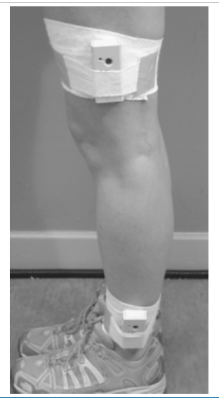* *previous studies that have used a range of different features to characterize acceleration signals [11], [14], [16], [17], [21]–​[24], [33]–​[35].*

*features were calculated from 2-s (128-sample) consecutive windows that overlapped by 1 s. The use of a 50% overlap between successive sliding windows has been shown to be effective in previous studies of activity classification [11], [38]. The choice of a 2 s window was motivated by previous studies by Nyan et al. [24] (2 s) and Wang et al. [14] (2.56 s) that had used similar length windows. If a window corresponded to a transition between two activities, it was excluded from subsequent analysis.*

*Wavelet analysis: With this approach, the original time-domain signal (maximum frequency f) is initially decomposed into a coarse approximation and detail information by low-pass filtering (bandpass [0, f/2]) and high-pass filtering (bandpass [f/2, f]), respectively [39]* *With wavelet decomposition, the half-band filters are designed to enable perfect reconstruction of the original signal and to avoid aliasing effects*

*Wang et al. [14] sampled accelerometer data at 50 Hz; therefore, our data were resampled to this frequency. used wavelet packet analysis to derive 33 features from a triaxial accelerometer signal.*

[*https://ieeexplore.ieee.org/document/4353438*](https://ieeexplore.ieee.org/document/4353438)

*Bonus info:* [*Wavelet levels*](https://rawpedia.rawtherapee.com/Wavelet_Levels#Contrast_by_Detail_Levels_vs_Wavelet_Levels)

*This slider lets you decide how many detail levels the image will be decomposed into. You can choose any level between 4 and 9 (the 10th level, called Extra, appears automatically when you select level 9). The higher the number, the more processing time and memory will be required.*

*C. Time- and Frequency-Domain Features  
De beskriver hvordan de udtrækker nogle forskllige features, som Mean, SD og 25th og 75th percentile samt principal frequency korreficions*

*For both classification problems, the optimal accelerometer placement for a single sensor was shown to be on the ankle.*

*In their study, Nyan et al. [24] collected data using two shoulder-mounted accelerometers so that their results are not directly comparable to those in this study.*

### Classification of gait patterns in the time–frequency domain

[*https://www.sciencedirect.com/science/article/pii/S0021929005003891*](https://www.sciencedirect.com/science/article/pii/S0021929005003891)

Man forsøger at bruge skulde placerede IMU til at classificere Gait aktivities, walking, and stair walking

In the experimental set-up, MMA1220D (Motorola, ±8 g) low g micromachined out-of-plane accelerometer and ADXL105 (Analog Devices, ±5 g) single axis accelerometers were arranged in vertical and antero-posterior directions at the shoulder of a garment … signals were digitized at 256 Hz sampling rate

Dyadic wavelet decomposition

2 s time duration of separated segments was used in gait pattern classification

In this paper, we use non-orthogonal wavelets first introduced by Mallat and Zhong (1992). The mother wavelet is the first order derivative of a cubic spline function and its coefficients are given in that paper.

Mantyjarvi et al. proved that applications of ICA and PCA with wavelet transformation to six channels of acceleration signals from the waist level give better classification rate than the original data by using three multilayer perception neural networks.

Moreover, the square value of the vertical acceleration signal can enhance the amplitude difference between two successive segments and a larger amplitude difference can give higher accuracy in time duration of the extracted segment for vertical acceleration signal.

### IMU dataset for motion and device mode classification

[*https://ieeexplore.ieee.org/document/8115956*](https://ieeexplore.ieee.org/document/8115956)

Kigger på IMU data til tracking aktivitets type og placering af sensore. Bruger SVM technicus

### Inertial Sensor Based Human Activity Recognition via Reduced Kernel PCA

<https://link.springer.com/chapter/10.1007/978-3-030-02819-0_34>

*“kernel PCA has been utilized for dimensionality reduction to deal with inertial sensor based human activity recognition”*

### IMU-to-Segment Assignment and Orientation Alignment for the Lower Body Using Deep Learning

[*https://www.mdpi.com/1424-8220/18/1/302*](https://www.mdpi.com/1424-8220/18/1/302)

Kigger på hvordan man kan aligne IMU data, ved hjælp af diverse AI teknologier. De genererer også selv ny syntetisk data

*“For this, we combine convolutional neural networks (CNNs) for local filter learning with long-short-term memory (LSTM) recurrent networks as well as generalized recurrent units (GRUs) for learning time dynamic features. The assignment task is casted as a classification problem, while the alignment task is casted as a regression problem.”*

### Head Trajectory Diagrams for Gait Symmetry Analysis Using a Single Head-Worn IMU

<https://www.mdpi.com/1424-8220/21/19/6621>

De vil lave gait analyse ud fra head-mounted IMU (Earbuds). De laver en opgørelse i x-y planet, som viser at hovedet svinger fra side til side når man tage hhv. skridt med hø og ve fod. Det virker ret smart at lave en ny x’ og y’ akse på subfigur D, alt pos y’ er hø skidt og alt neg y’ er ve skridt

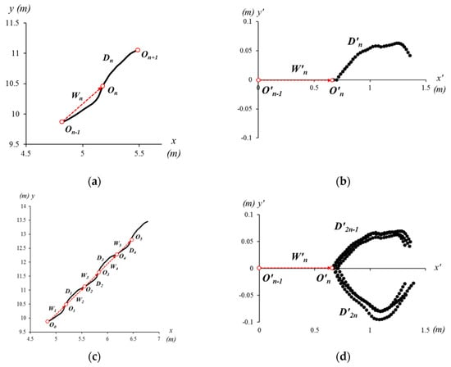

### Wavelet-Based Analysis of Physical Activity and Sleep Movement Data from Wearable Sensors among Obese Adults

<https://www.mdpi.com/1424-8220/19/17/3710>

Recently, the use of MEMS-based wearable inertial sensors has grown in both physical activity [28] and sleep research areas [29]. … One of the important measurements of the inertial sensors is to detect periodic limb movements in sleep and sleep quality [30,31,32] … wearable sensors extensively monitor movement disorders [33,34].

body worn belt Move Monitor + Dynaport sensor … device includes a triaxial accelerometer (sensor range and resolution: ±6 g and ±1 mg, respectively) and a triaxial gyroscope (sensor range and resolution: ±100 °/s and ±0.0069 °/s, respectively) … sample frequency of 100 Hz,

sleep measurements were conducted using a single waist-worn wearable sensor, and analysis relied on an accelerometer-based measurement algorithm to estimate total sleep time.

A 1-s moving window evaluated the mean and variance of RA,xz time series. If the window means of RA,xz was bounded between 0.97 g and 1.02 g, the window variance was below 0.1 g, then, the data were categorized as sleep data (R_XYZ_Sleep). This was determined through a pilot study, where we found that breathing in subjects does not change their resultant acceleration more than 0.02 g at their lower back while laying down in supine, or on either side.

If the time gap between local peaks is less than 2 s, it is considered as being within the same transition. … If two peaks are at least 2 s away in time from each other, we treat them as if they are in two different movements, and thus in different transitions

Analysis: Det virker til at de beskriver deres valg af walelets ret grundtigt, det kan jeg dykke videre ned I måske.  
Wavelet-Based Frequency Analysis: For frequency analysis, Fourier transforms is the first choice to determine the frequency content of a signal. However, the frequency characteristics of inertial sensor signals change over time, and Fourier transform does not offer temporal localization. Wavelet transform is more promising in both the time and frequency domain information of the signal. Creation of a Morlet Wavelet: In order to make a Morlet wavelet, we can create a sine wave and a Gaussian wave and multiply them point by point. Both the sine wave and the Gaussian wave must have the same number of time points and the same sampling rate. The frequency of the wavelet is the frequency of the sine wave. The frequency of a Morlet wavelet (center frequency) is actually a band of frequencies.

Sampling rate of the inertial sensor signals (f = 100 Hz). The wavelet time was chosen as 4 s, and the cycles of the Gaussian window are set to be from 12 to 14, which is relatively large

We also showed that the root mean square of transition acceleration during sleep among non-obese participants was significantly higher than that of obese participants, thus affecting the quality of sleep. We also found that the total number of transitions during the night were significantly less for obese individuals (Figure 19) and their average sleep time was less than that of the non-obese participants (8.3 h versus 9 h) (Figure 20).

## Video / Lidar

### Privacy-Preserving In-Bed Pose and Posture Tracking on Edge

Har ikke adgang

### AI-Driven Privacy in Elderly Care: Developing a Comprehensive Solution for Camera-Based Monitoring of Older Adults

Bruger YOLOv8 model, til at lokalisere box bounderies og til pose keypoint 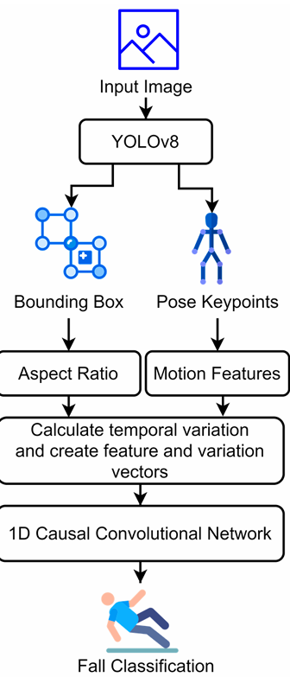

Denne artikle er ikke læst til ende, kun skimtet

### Optimal Image Characterization for In-Bed Posture Classification by Using SVM Algorithm

Vil klasseficere 4 senge positioner, som er: Ryg, mave, og de 2 side leje

Det gør de ud fra still billeder

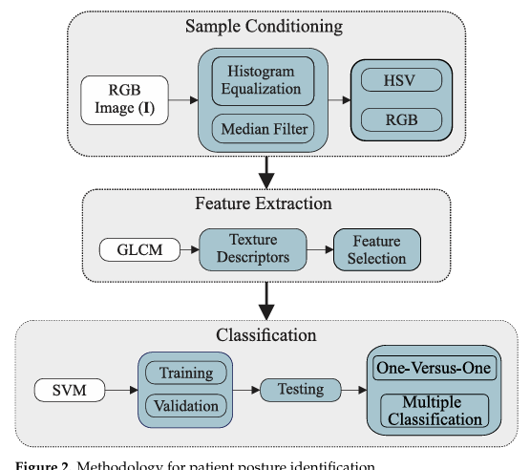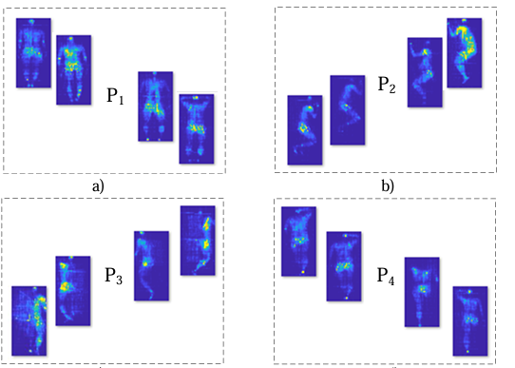

MobileNet and DenseNet121 obtained the best results, burger eller SVM til benchmark

*Fremgangsmåde til feature extraction: First, histogram equalization is applied to the samples, aiming to highlight pressure areas. Second, the sample images are converted into Red, Green, and Blue (RGB) and Hue, Saturation, and Value (HSV) color spaces. In the feature extraction phase, the images are processed to obtain their statistical properties, and the best alternatives are selected for further categorization*

### Privacy-Preserving In-Bed Pose Monitoring: A Fusion and Reconstruction Study

Er ikke læst grundigt

Using long-wave infrared (LWIR) camera, for at få det anonymiseret-kindda

we propose using a conditional Generative Adversarial Network (cGAN) to reconstruct nonprivacy preserving visible images using privacy preserving LWIR image

HRNet [33] as the backbone network architecture for human pose estimation as it is currently the SOTA model

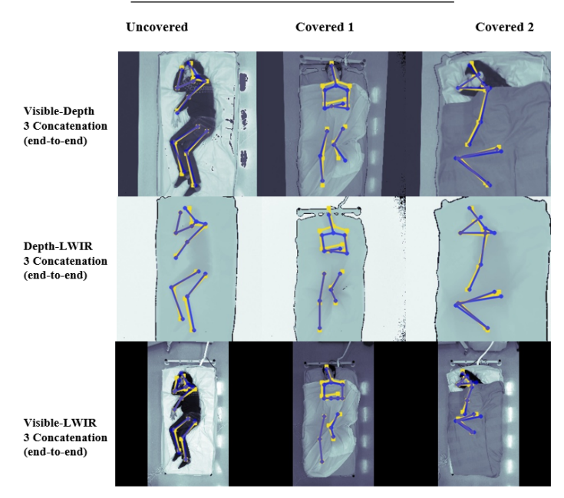

### Effects of camera viewing angles on tracking kinematic gait patterns using Azure Kinect, Kinect v2 and Orbbec Astra Pro v2

## Random viden

### Motion Artifact Detection and Reduction in Bed-Based Ballistocardiogram Ballistocardiography (BCG)

<https://ieeexplore.ieee.org/document/8620204>

<https://en.wikipedia.org/wiki/Ballistocardiography>

Måler hjerte aktivitet ud fra det blodflow som er i decending aorta og det derved generede rekyl

(Måske jeg vil kunne se dette i mine IMU-data)

One less intrusive option is actigraphy [3] which uses accelerometer data to classify sleep and wake periods based on body motion.

Support vector machine (SVM) classifier to classify the specific type of movements such as hand, leg and all other movements.

Based on comparison to ECG R-R intervals as reference, it is also shown that Wiener smoothing based B-B interval estimation algorithm is more accurate than the AR model based approach. This can be attributed to the fact that Wiener smoothing uses both past and future frames for estimation but the AR model prediction is based exclusively on the past values. However, it is important to remember that Wiener smoothing relies on the assumption of stationarity of the underlying parameter dynamics.

Det ser ud til at de er grundige i deres forklaring om hvordan de fjerner motion artifakter, hvilket jeg måske kan dykke længere ind i hvis nødvendigt

### An Inertial-Based Wearable System for Monitoring Vital Signs during Sleep

<https://www.mdpi.com/1424-8220/24/13/4139>

Bruger 5 IMU, til at monitorere Vital signs during sleep.   
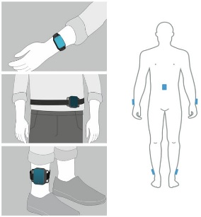J motion signals undergo band-pass filtering in two frequency ranges associated with respiratory ([0.08, 0.6] Hz) and cardiac ([0.7, 1.7] Hz) activity during sleep 𝑇𝑘=30 s symmetrical windows

Følg lige dette link: <https://soeg.kb.dk/discovery/search?query=any,contains,sensor,AND&query=any,contains,movement,AND&query=any,contains,sleep,AND&tab=Everything&search_scope=MyInst_and_CI&vid=45KBDK_KGL:KGL&mode=advanced&offset=0>

Der kan være flere gode artikler, Head-worn,



### Measurement of Functional Use in Upper Extremity Prosthetic Devices Using Wearable Sensors and Machine Learning

De burger Random forrest til at klassificere bevægelse, hvor de bruger video som ground truth. De forsøger med variable chunk længde men finder at fixed længde er bedst. De bruger chunk størelse på 800-sample points (4sek).

IMU (ADIS16400BMLZ, Analog Devices) that was sampled by a microcontroller (Arduino Pro Mini) at a rate of 200 Hz

Kun 5 subjects, og 5 klasseficeringer FAABOS

The sensor data were categorized into either functional use or non-functional movements using the JavaML Random Forest classifier with its default settings [69]. The Random Forrest parameters were 100 trees max, random seed set to 123 for repeatability, no limit to the depth of the trees, no back fitting, and four features randomly selected at each split. We used the Random Forest classifier because it is known to perform well over a wide variety of data sets and has shown success on movement data in the past [20,37,40]. The data were classified in two different ways: intra-subject 10-fold cross-validation testing and inter-subject leave-one-out testing. In intra-subject tests, the training and testing datasets were drawn from the same subject. In inter-subject tests, the training dataset contained data from every subject except the subject in the test set. The patient and control groups were evaluated separately.

The intra-subject method yields the best-performing models and captures subject-specific movement patterns that are problematic for inter-subject modeling. While this requires training a new model of each patient, we are currently researching methods for reducing the amount of training data needed

# Sleep

## Ted talk with Matt walker

### Melatonin

Melatonin producers naturligt I vores hjerne i området kaldet Pineal Gland, 2 timer inden typisk sengetid. Det påvirker kun timing af vores søvn. At bruge det som sleep Aid, er ikke så effektivt som forventet. Det øger 3.9 min, quality/sleep effeciency by 2.2procent.

### Effects how much you eat

Leptin (Fuldness) og Ghrelin (Hunger), appetit hormoner. Når man sover mindre vil man producere mindre leptin og mere ghrelin. Og vi søger mad som har et højere kalorie og sukker indhold (energi)

### Insomnia

Svært ved at falde i søvn eller svært ved at blive i søvn, eller ikke føle sig udhvildet efter søvn.

THC (Cannabis) , Alcohol, vil ikke øge kvaliteten af søvn, tvært i mod.  
Cognitive Behavioral Therapy of Insomnia (GBTI), er terapi, og studier viser at dette virker meget bedre end suppliments, og at det også efter behandlingne er stoppet.

### Dream

Creativitit,   
REM-slepp dreaming, take the painfull out off ter  
Hvis vi REM-drømmer om dagligdags event, bliver vi bedre til det.

### 6 Tips

1. Regularity
2. Tempuratur, keep it cool (lige over 18 grader)
3. Darkness, det frigiver melatonin
4. Walk it out, efter 25 min søvnløs, så gør noget andet da vi skal lære at sengen er søvn generator.
5. Alcohol and caffeine,   
   Caffeine, halveringstid på 5-6 hours og det kan ændre søvn kvaliteten og minske stage ¾ NREM søvn.  
   Alcohol,   
   1. virker Sedation/Beroligende hvilket minske mængden af stage 3-4 søvn, da hjernen her har brug for at være aktiv   
   2. Øger frigt and fight  
   3. Kan blokke REM sleep, som er med til at styre os emotionelt og creativit
6. Wind down routine, Lav en routine, 20-30min inden søvn.

### Stages of sleep

NREM (Stages 1,2 og 3/4) og REM sleep.

Vi har mere stage ¾ søvn i starten af natten og mere REM søvn sidst på natten.

### Memory

Vi skal sove før og efter læring. Da vi har brug for at have clearet hjernen ud inden vi lærer og vi skal efterfølgende sove for at lagre det vi har lært.

Replay og scorring vores læring i søvn.

### Alzheimer

Memory loss and/or decline. Beta-amyloid and tau proteins

Less than six hour will have higher Beta-amyloid level. Og bare efter en nat med mindre søvn vil være have mere beta-amyloid protein.

Maiken Nedergaard, har fundet cleansing system, kaldet det glymphatic system. (Glia cells). Dette er mest aktivt i NREM-søvn. Noget af det som renses ud er Beta-amyloid.   
Hypotese, kan man måske kurrere Alheimer ved at få bedre mid-age søvn?

### Amygdela

Ved at få pluselig ændret søvn, sleep depried, bliver amygdela omkring 60 procent mere aktivt.

Prefrontal cortex, commando contralen, styrre amygdela, kommunikationen mellem dette central og amygdela er dårligere og derfor overreagere amygdela, da vores control system ikke virker.

REM søvn, er vores egen emotion terapi.

### Immunity

Lees then 7-hour, vil influensa blive langsomere behandles. Søvn øger også sensitiviteten for at kunne modtage flu.

## Sleep/Wake Physiology & Pharmacology With Dr. Schneider

<https://www.youtube.com/watch?v=XA9V8bUi0ps>

<https://www.sciencedirect.com/science/article/pii/B9780128040744000017?ref=pdf_download&fr=RR-8&rr=8c3f25afcc031d06>

Det er godt for memory storing og cleaning out old stuff.

insomnia is the inability to fall asleep, hypersomnia is characterized as excessive daytime sleepiness

### Sleep arcitekture

Vi har nogle forskllige søvn stadier.

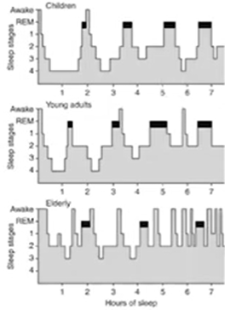 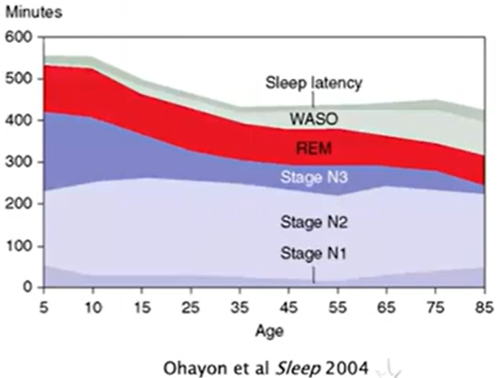

Vi har ikke kun dikret stadier, men vi kan inddele vores hjerne aktivittet i svingerninger, hypnodensity plot

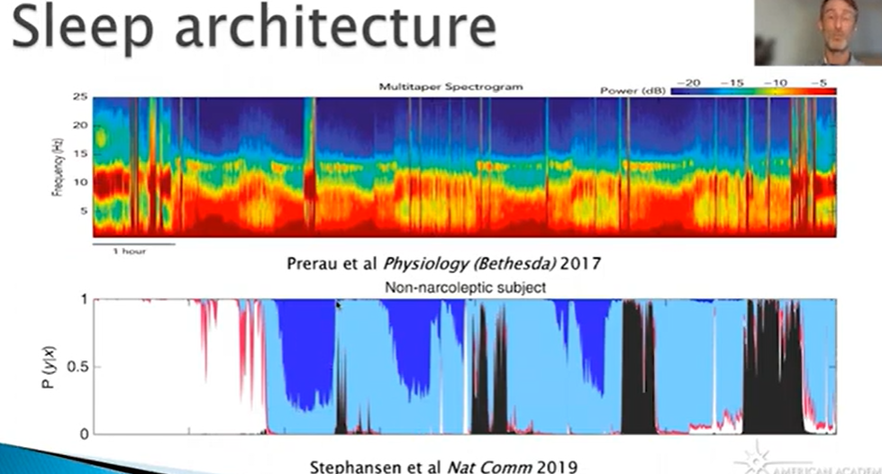

Der sker en ændring med aldring af din søvn  
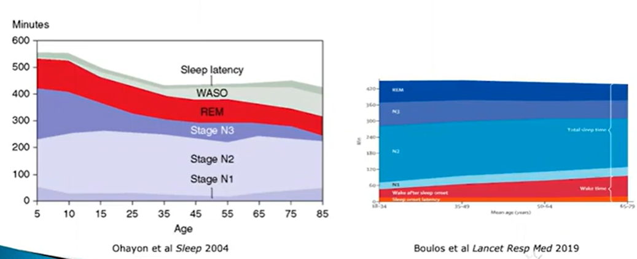 Vi skal ikke bare have 8 timer, vi skal også have nok af hver del af de specefikke stadier.

Kaffe blokerer adenosin virkning, og der blocker evenen til at føle sig træt

Amphetamine, vil også kvikke os op, og det er meget afhængings skabende.

Neurotransmitteren, Dopamin, vil fremme wakefulness

Wake promoting system:

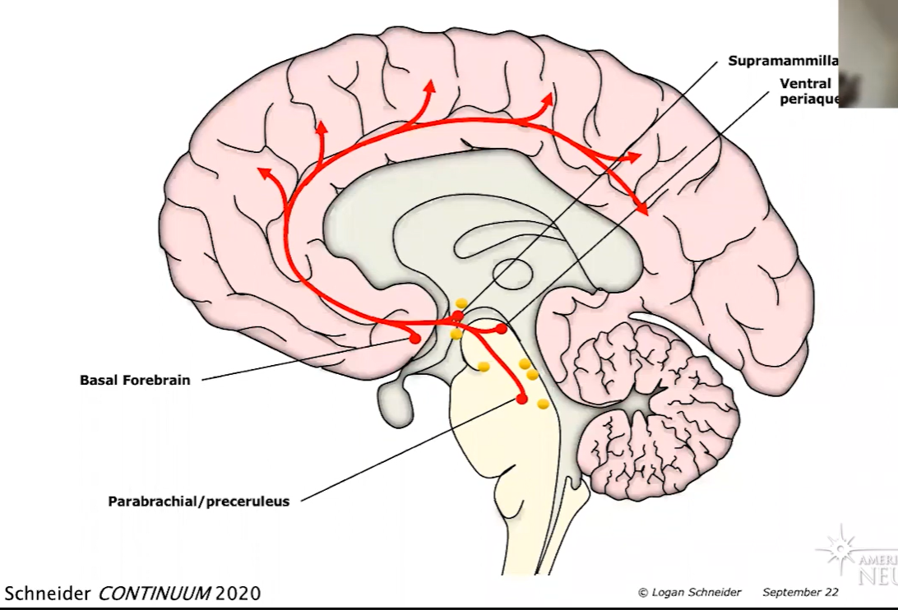

Dopamin er den mest pobten promotiong wakefulness transmitter

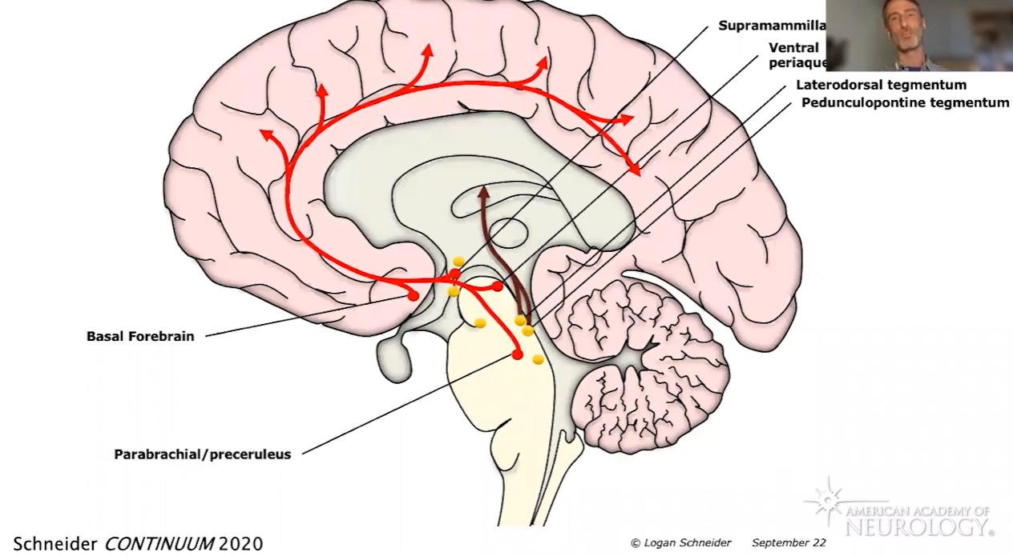

De brune streger er dem som giver tidstedstedeværelse/conscious, og alert system, så hvis vi ikke har dem vil vi kun være vågne med ikke tilstede.

Men hvis man til gengæld kun har aktiveret det brune, men ikke det røde (vågenheds systemet) så vil vi drømme.

Vi har

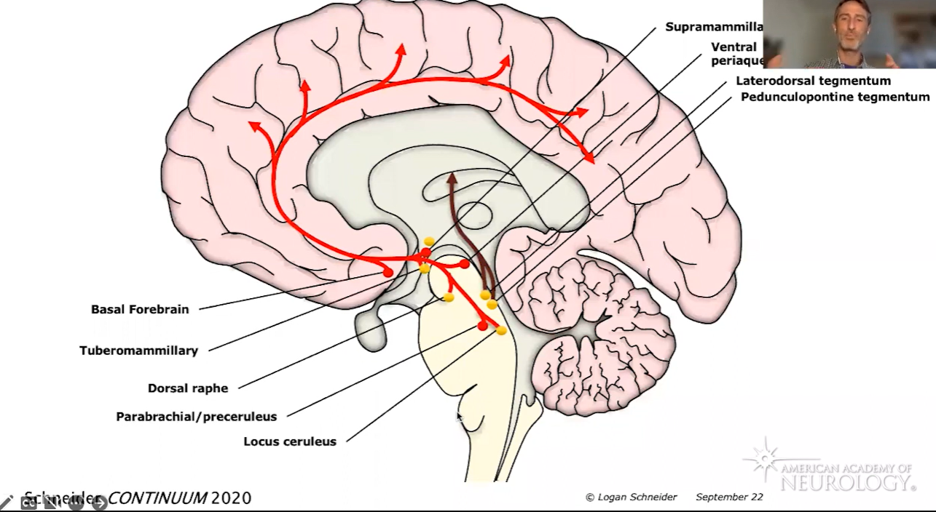

Modulatory system, som bibeholder organers motivation,

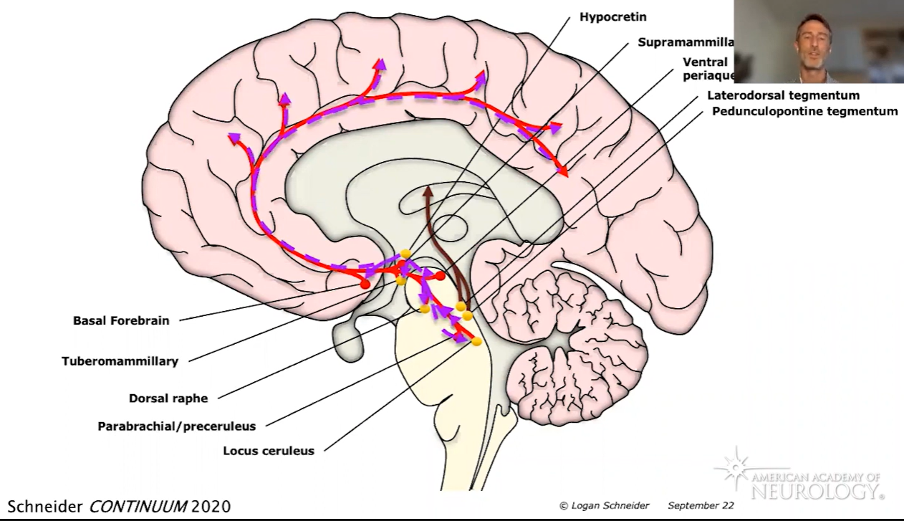

Hypercretion, promote awake, sleep steage stabilasor.

Locus ceruleus, påvirkes fx. Af lys, dette ses i musse ekparimentet hvor musen bliver aktiv/vågen øjeblikligt når dette center aktiveres ved lys (gennem et neurotransmitter stof)

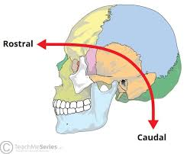

Sleep promoting center

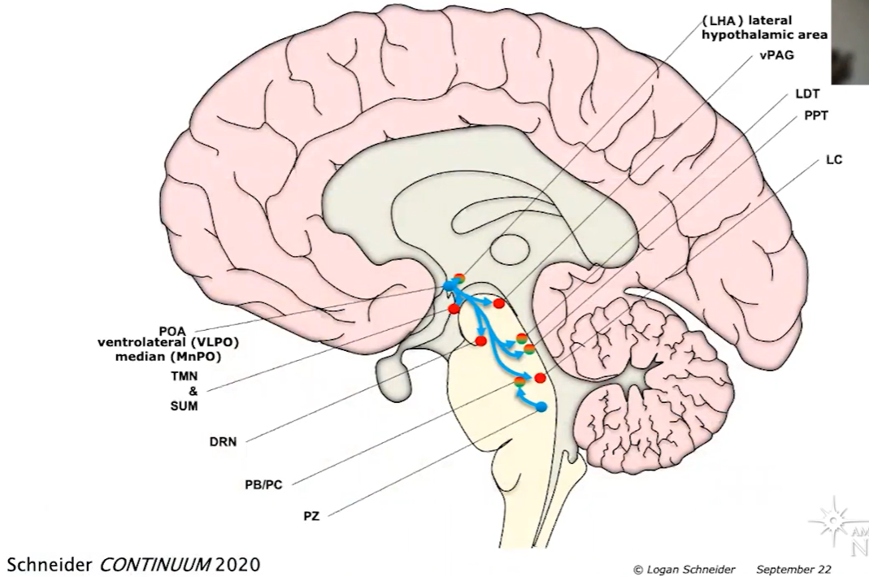

MnPo, kicks thing of, hvor VLPO holde os I søvnen, dette sker gennem GABA og Galion.

I stadierne vågen og REM-sleep er det Acetylcholine som bevirker et meget aktivt cortex og thalamus.

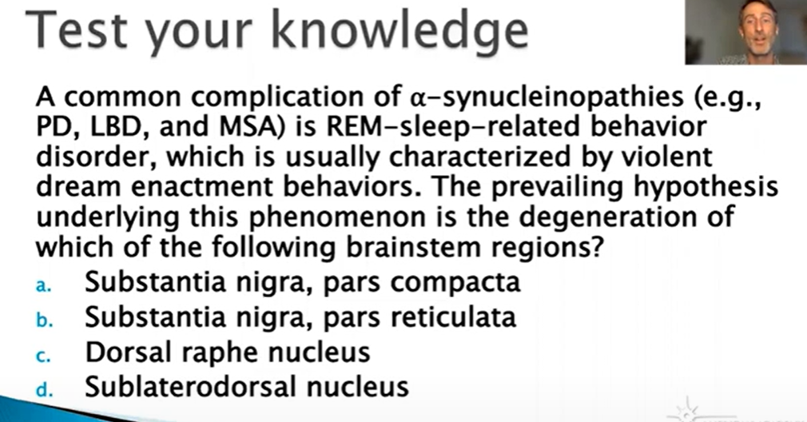

Svar: D

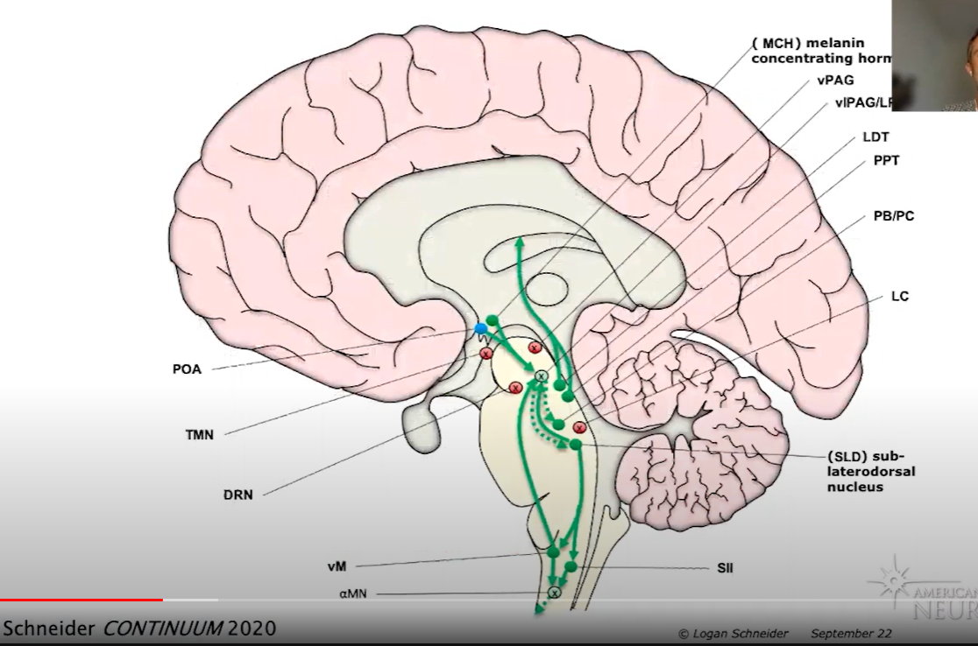

Dette er så et drømmestadie, hvor LDT og PPT er aktivt, og vi er derved ved bevidsthed, men vi er IKKE vågne, derfor drømmer vi. Disse to centre vil være deaktiveret i Non-REM.

Der er GABA i POA/PreOptic area, som holder os i søvn stadiet, mens vi også har MCH aktivt, som er temperatur reguleret melatonin producerende. Som også inhibitere Dopamin producerende områder i v|PAG/L…

Det er vigtigt at det er temperatur reguleret, da kroppen i REM er paralyseret og derfor kan vi ikke ryste os til varmen. Så det er et sikkerhedssystem, som vil vække os hvis temperaturen ændres drastisk.

SLD: Promoting REM over Non-REM, og sikre at kroppen er paralyseret i REM-søvn. Den sender signal til SII som har inhabatorisk synapser til motorneuron aktivering i alpha-MN i vores spinal core. Der sendes også signal fra SLD til Ventral Medulla (vM) som også sender signal tilbage for at fastholde og støtter søvn gennem v|PAG, men det sender også signal direkte til Alpha-MN.

Det er bla. Ved Parkinsons syndron at SLD bliver skadet og derved sker der ikke denne afkobling/bremsning af aktionspotentialer i Alpha-MotorNeuroner.

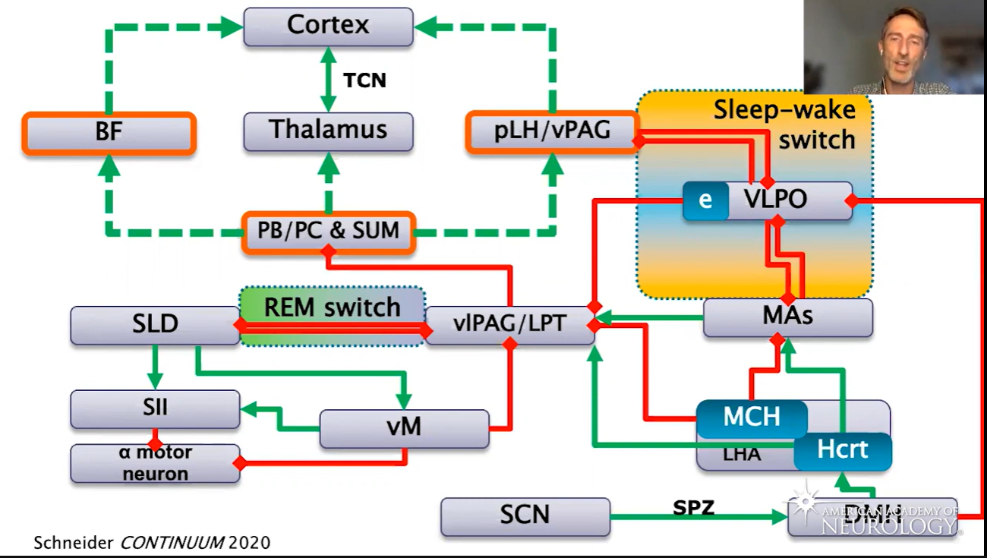

SCN, lys input fra ratina. DMH, er alverdens sensorisk input, som sult osv.

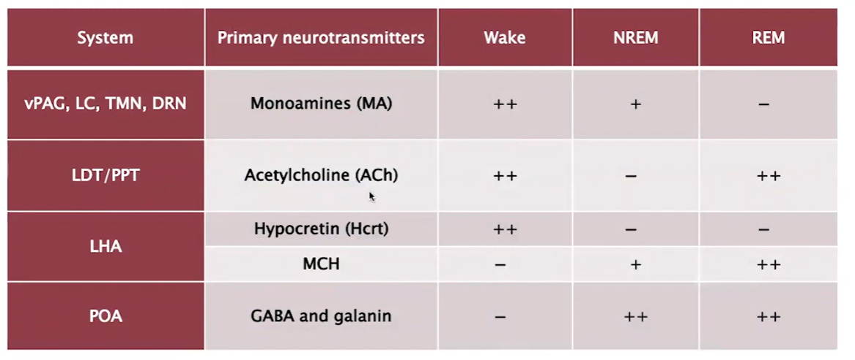

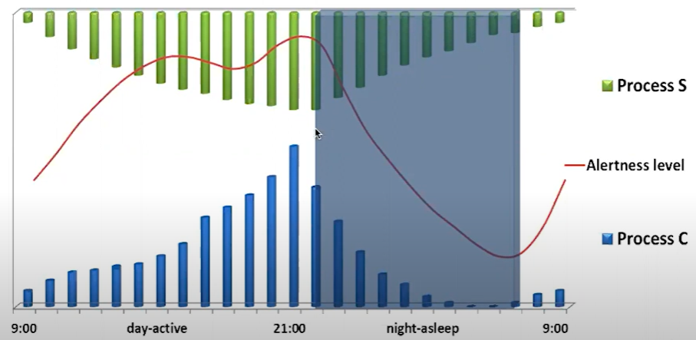

Process S, Sleep-drive, skabes ved mathorn, tests osv. Process C, er vores alerting system,

Hvis du sover 5-6 timer pr nat og vil modvirke drowsiness/Træthed, bruger mange napping og caffine, hvilket påvirker Adenosine, som er et breakdown signal at vi har forbrugt ATP. Homiostatisk regulering af søvn, da det er et udtryk for at vi har været aktive.

Caffeine vil blokke vores ATAR-receptor, som gør at vi ikke modtager Adenosine i den post-synaptiske celle. Hvilket er det som giver en træthedsfornemmelse. Det modvirker altså ikke at vi er trætte og har brug for rest, men blot opfattelsen heraf, vi undertrykker derved vores trang til pauser.

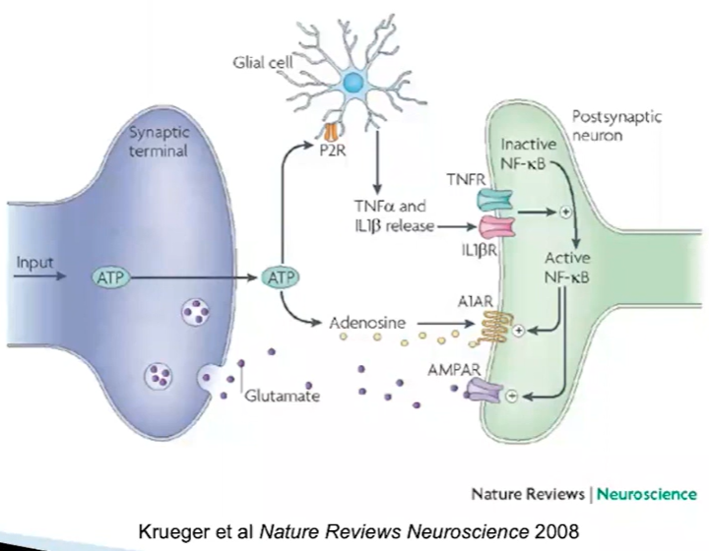

Andre stoffer/medicin man bruger mod træthed er Amphetamine, hvilket er stærkt vannedannende, da Amphetamine produktionen øges og at reuptake øges. Dette vil i sidste ende give en øge produktion af dopamin og nor-adranalin, hvilket er det som gør os afhængige.

Histomin

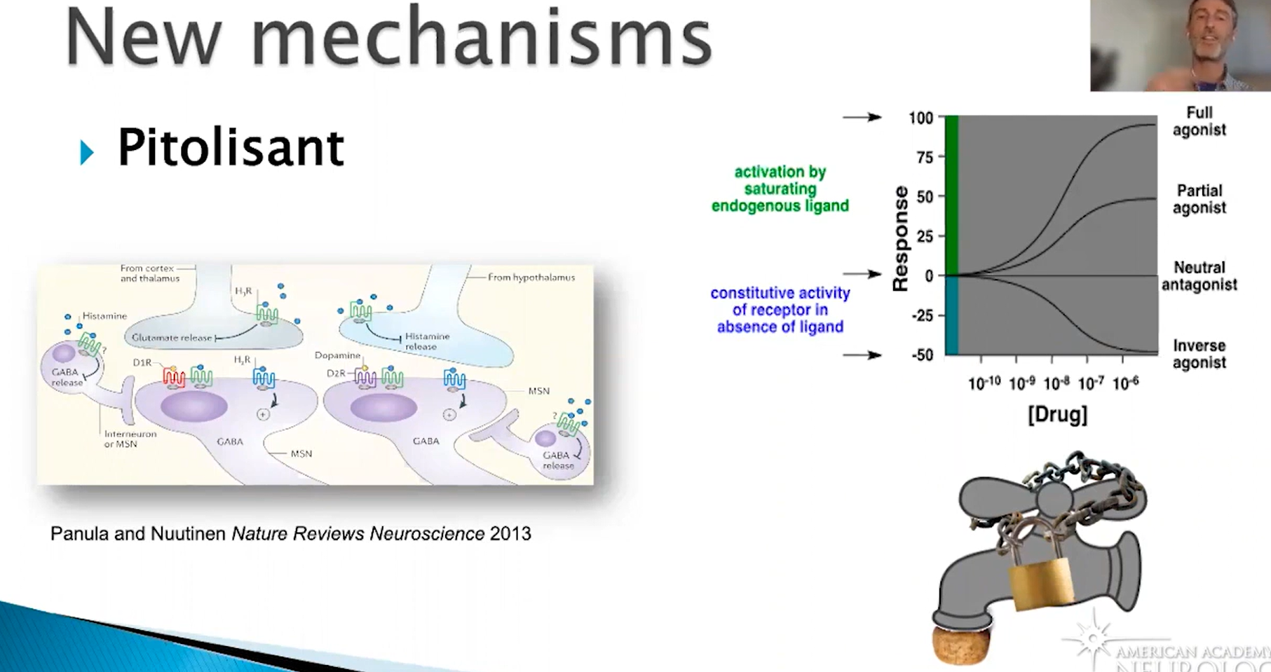

Melatonin, er godt til at time din søvn, hvis du har brug for at time din søvn

Lys skal være Upon wakeing

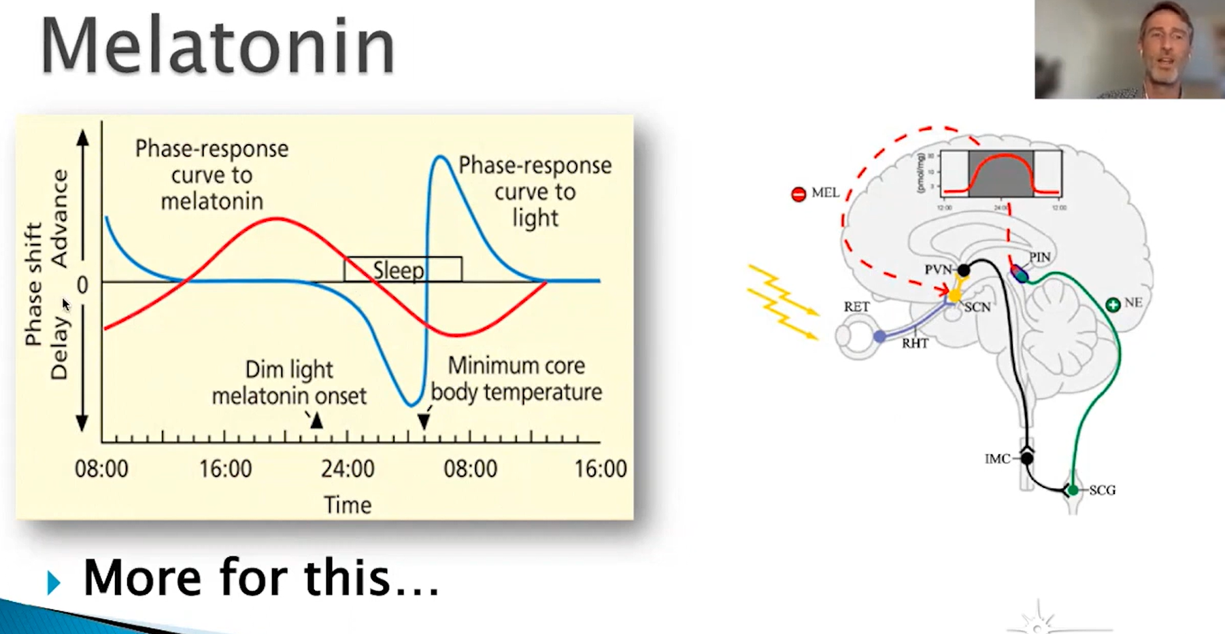 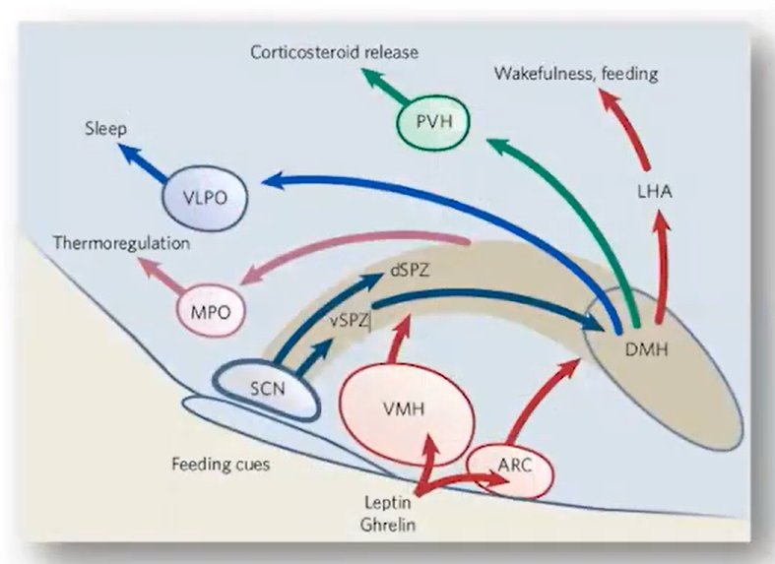



### Restless leg syndrom (RLS)

It’s a brain disorder, have an urge to move their legs. Sometimes its not relief by moving their legs, but can be. It’s not painful, but just ignoring and irritating.

Typically, one or both legs, but in worse case can it spread to other parts of the body, e.g. Torso.

It’s corresponding to the Iron-level in our body, but normally by night, but can also attempts when you are forced to be inactivity, e.g. Flight or car traveling.

5-10 % of the population. More western and northern Europa population. 20% of pregnancy women have the condition or symptom. The frequency doesn’t need to be constant, from once a night to once a month. But can come and go, but patient tend to be faight and flight active, and thereby are we more aware, so not direct relation, but there are some interrelation with stress. You are not inheriting the RLS, but you get higher risk with certain gens and therefore runs in family. More patient are elderly, but it may not be related to aging, but not to change to have more distribution and medication.

Periodic libs movement in sleep can be confounding with people with RLS.

Triggers, chemical triggers e.g. Iron do have an effect. RLS-patient have lower brain level of Iron, Dopamine receptors can be defected. Dopamine is produced and transported in the brain with the help of Iron, so its interconnected. Anti-drugs can do it worse, such as Antidepressive, antihistamine, anti-… and sleep medicine, followed by e.g. Alcohol, caffeine, etc.

Treatment: Reduce: caffeine, nicotine, alcohol. U-curve for activity, so inactivity and hyperactivity can make it worse. Can be simulated/relifted with cold, heat, compress solution. Weighted blankets have not been studied; doublet edged. Subjective symptoms and treatment.  
Iron can directly help, but don’t take to much, it can make other disfunction, but go to your doctor and make a control of your iron level.

Can be compared with leg-cramps. But are more difficult to diagnose.

There is not long-term effect with RLS. Hemoglobin level need to be checked first, then the Iron level. No objective test but are completely based on symptoms. But if there are other reason to believe in sleep disorder then an overnight test can be recommended.

IV-Iron infusion can be one treatment but are not the first step. Medical can be seizure or nerve pain medicine. In most severe cases, and the first medical treatment is opioid. The reason is a shutdown of the Dopamine shipping ports, and thereby can it be worse if you take the wrong medical.

### RBD – REM sleep behavior disorder

They move in response to there dream.

Link to PD: When its rache the barin, its hit the nose-neuron and later to the basa gangliger, and afterwares the memory. RBD are not common the browred population. Most RBD patients will develop PD, some quickly and some later on.

There is deferent variation of PD.

+190 persons in cohort, in flowing every 18 mouth  
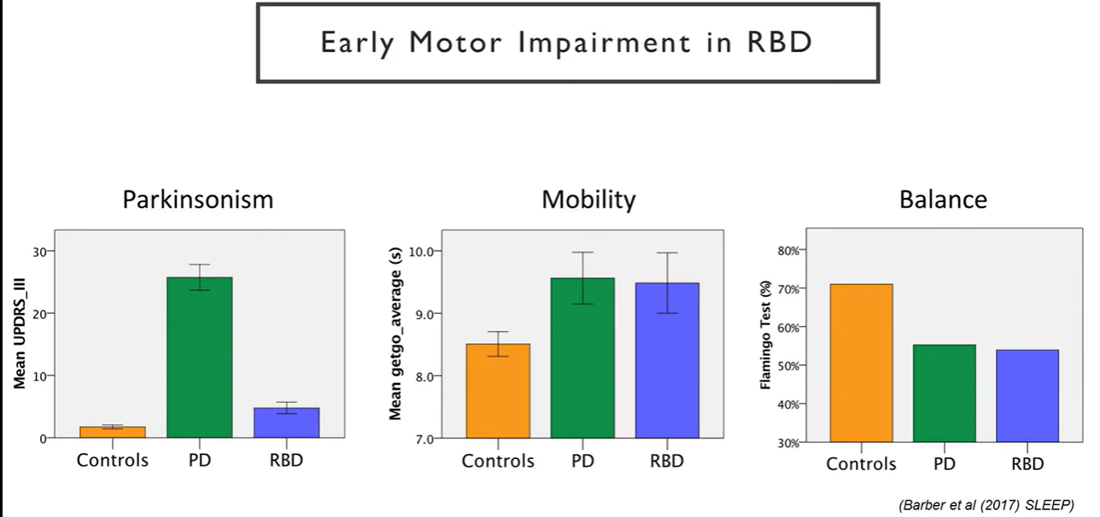 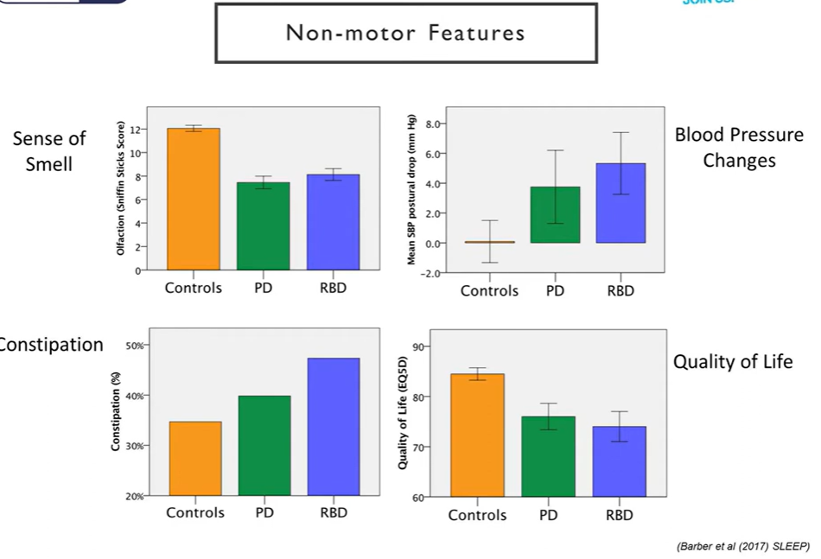

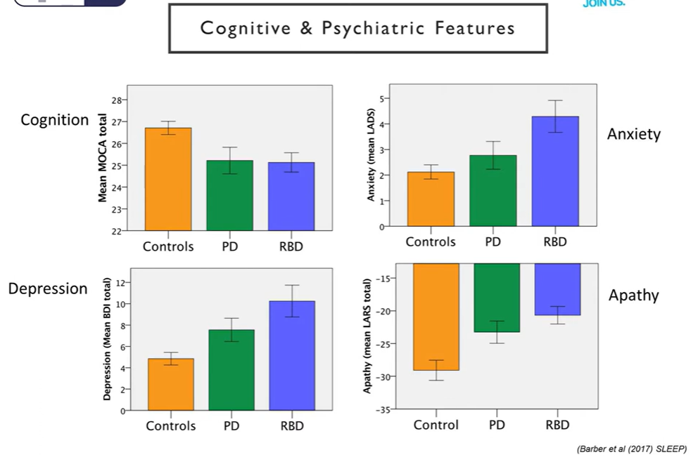

RBD have also mobility and balance complications, and there QoL are also present and RBD are more depressed than PD.

LRRK2 (3% of PD) and GBA (Sees twice as commonly for pt with RBD than PD) are to genic mutation.

RBD can be led to a subclass of PD.

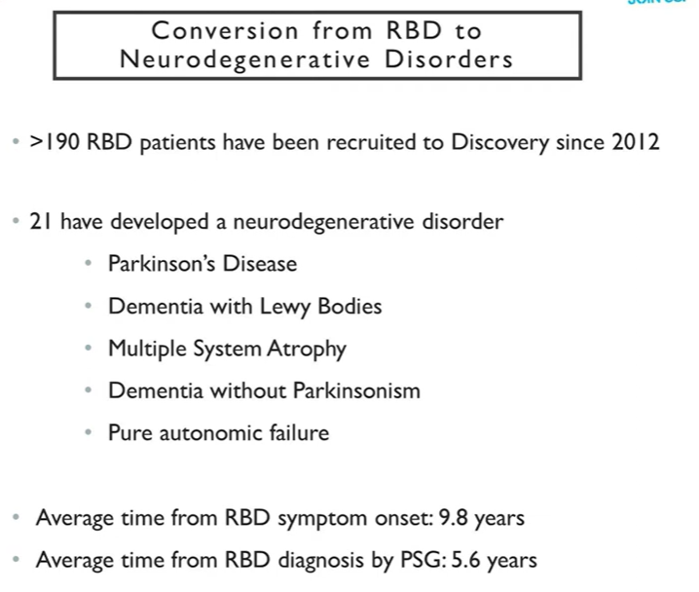 around 10 PT is PD out of the 190 after ca. 13 years

### Dementia and Alzheimer’s

Dementia is a syndrome, affecting everyday activity

Causes by: Strokes, Medical problems, neurodegenerative disease (Typical age related).

Neurodegenerative disease: The nerve cell will reduce the size of axons and branch. In macroscope we can see atrophy.

In an Alzheimer will there be Amyloid plaques (A-Bata) beteewwn the neurons and the neurons will be smaller than normal. Inside the cell will there be trangiels which are full of tau (Is a little chemical that maintain the axon and network of the cell, without that will the microtubio be destroyed).

Symptoms:  
- Early sign are forgot details of daylife events.   
- 60-70 y.o.  
latere effects can be langure disorder, depression, exiriting, planning,

Reason for memory loss: Shrinkage of HIPPOCAMPUS, and here we can find the tau and plaques. Its in hippocampus we have the memory.

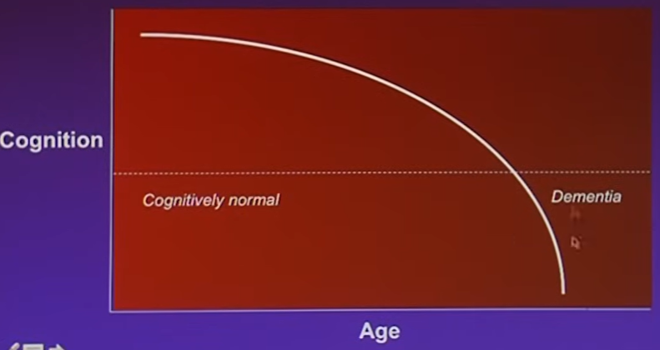 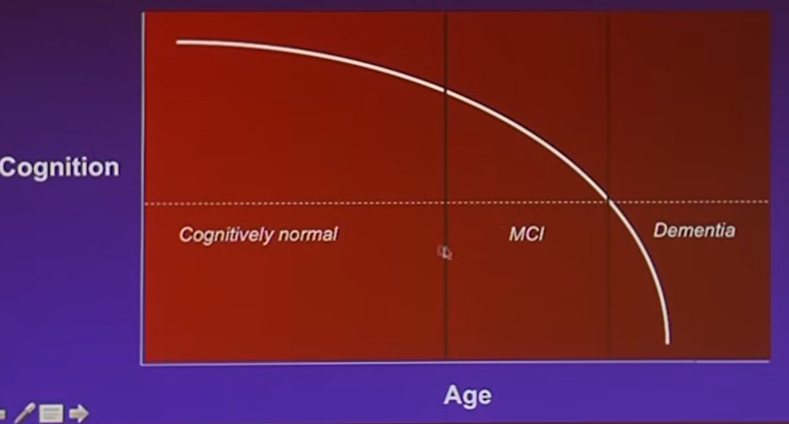

Can we diagnose the erlyer, we can perhaps find Mild Cognitive impairment (MCI). Founding’s: forget small events details, findings words. Its can also be totally normal

20-40% of people with MCI will develop Alzheimer.

How can we diagnose them? Can we measure the size of hippocampus, so by track the size over time.

Can be detected in a PET-scanner, with amyoloid.   
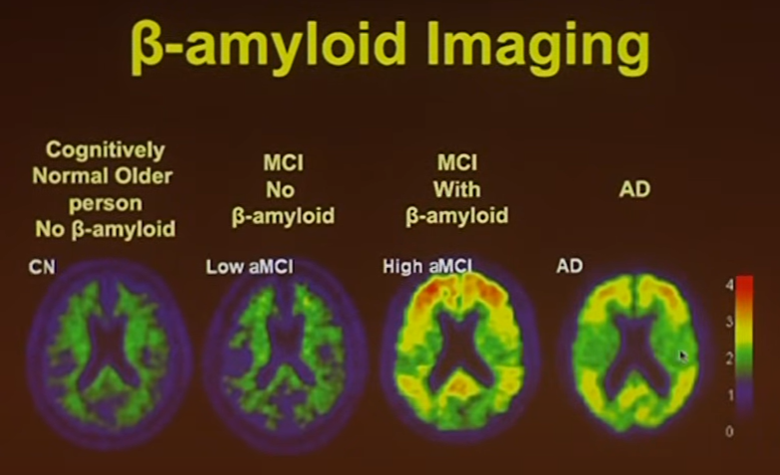

Current treatment.

Effect: Reduce the acetylcholine production,

Anti-amyloid, that hits the Beta-amyloid, e.g. Bapineuzumab, but it don’t have the clinical benefits. So we need to try it treat them ealyer. Can we clean up tau instead?.

Can we provent it? By cognitive and physical activity and though diet / vitamins / subplements.

(Highest excerisi 150min per week, have the lowest amyloid level.)

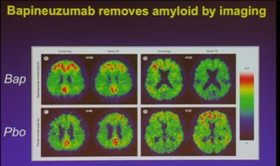

### Frontotemporal dementia (FTD)

Most common dementia disease in people under 60 years, 40% familial (mayor contribiuted to the gens), 10% dominant.

Frontotemporal, is our personality, empathy. Typical the right side of the of the lope when its behavioral, can be an result if head-trauma (physical accident, e.g. football, motor viracal accident).  
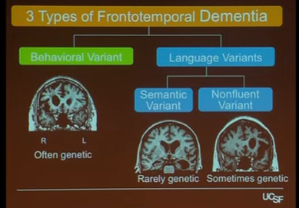 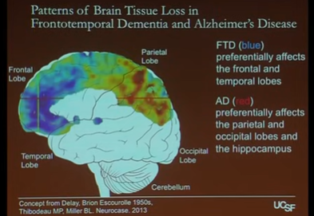 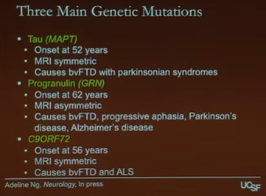

Twice as fast than Alzheimer's disease. It’s the tau that spreads from cell to cell, its can perhaps be treated.

Loss of Empathy, is confounder of FTD

C9- are a common mutation that result in dementia in Finland, Germany and France.

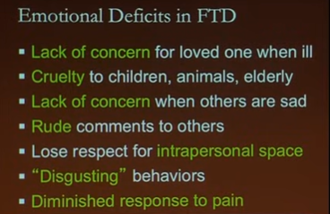

### Parkinsons

1817 – James Parkinsons

Second most common neurodegenerative,   
Resting tremor, Bracdykiesia, slow movements, rigidity (Clokking rigidity)   
95% get symptoms after age of 50 years. 3 men to 2 women.   
More cases due to longer lifetime in common.

Substantia nigra are involved. PD-patients have alpha-synovia proteins postmortal.  
5 stages in 1967, but new findings were found in 2006. Such as, sleep disorder and smell disorder (Is some of the first sign of PD, way before the unset of motor tremor).

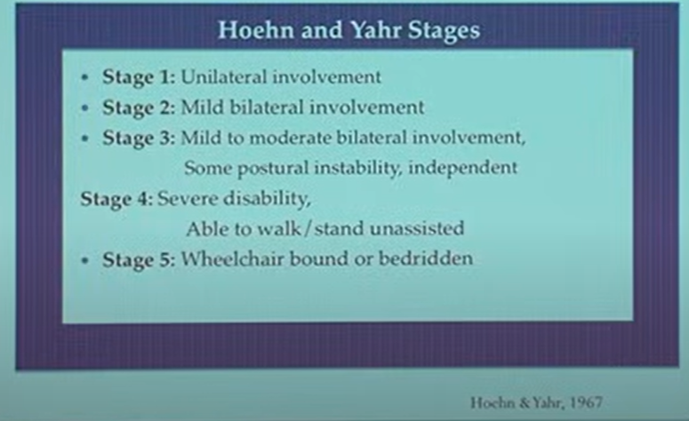 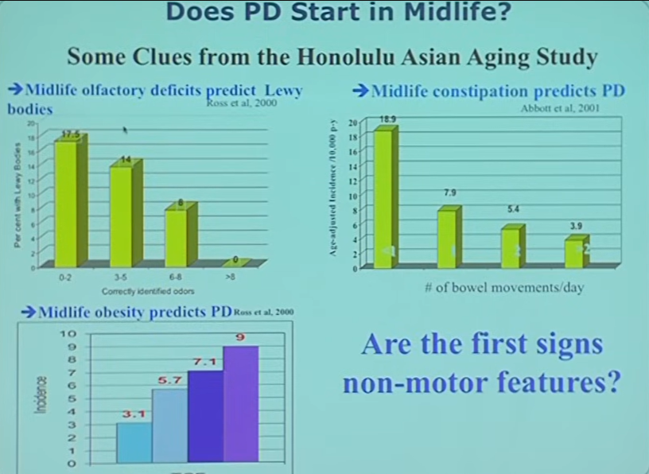

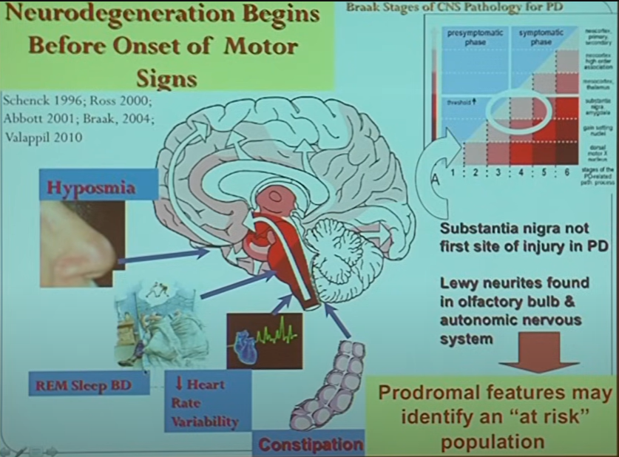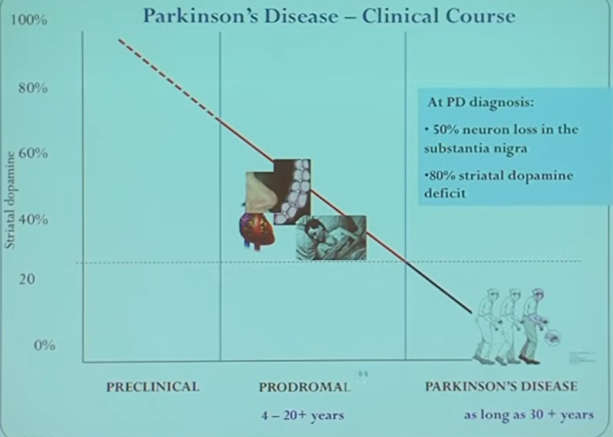  
Some of the first sign, before onset of motor signs.

**The goal is to slow and halt progression.**

Treatment are the same as the early 80’ish ** is regulation the dopamine   
first Levodopa, then Duopa, first pills then infusion.

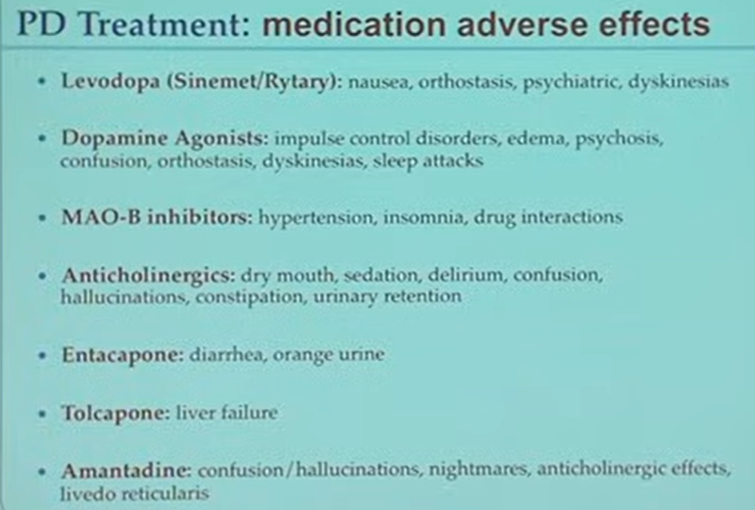 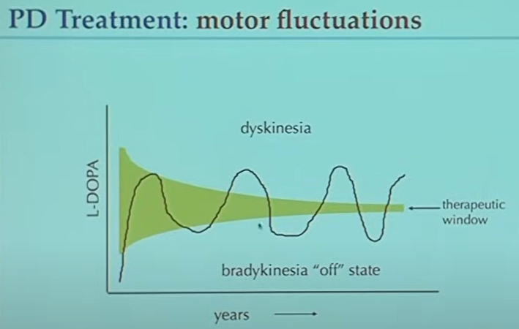

Dyskinesias, is a side effect of Levodopa, it’s a unvoluntary movement in the hole body, including movements similar to tics

Treatment device is a Deep Brain Stimulation (DBS), kind of a pacemaker that stimulates small parts of the brain. Implanted in basal ganglia, which are quite critical area to work in.  
Don’t last forever

Preventions, activity can reduce the risk of PD.

Risk: Pesticides, head injury (70% people with head injury got PD, the gene Alpha-synuclein, and head injury give you 100% risk of PD), gender,

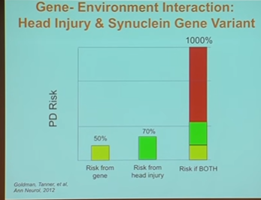 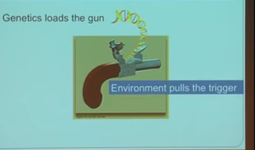 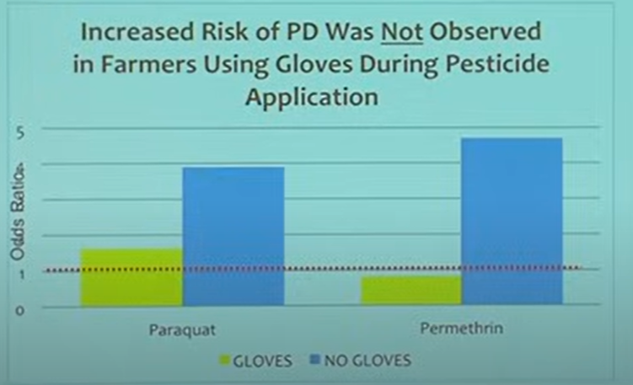

### Parkinsonism from book chapter 92

#### Prevalens

REM sleep behavior disorder occurs in up to 50% of PD patients and notably often starts years before motor manifestations.

Only a small percentage develop parkinsonism before age 45 years  
Affects 2% to 3% of adults older than 65 years.   
About 0.9% among persons aged 65 to 69 years   
5% among persons older than 80 years,   
1.5-fold male preponderance.

Indeed, more than 10% of patients have atypical parkinsonism characterized by different neuropathologies

Dementia with Lewy bodies (DLB) is the second most frequent cause of dementia after Alzheimer disease. These patients develop cognitive impairment mostly affecting visual-spatial performance, early hallucinations, and parkinsonism (frequently levodopa sensitive), with fluctuations of alertness and vigilance over days or weeks.14 (RBD er også tidlig indikator for DLB)

**Lewy body demens (DLB)** udgør ca. 4 % af alle demenstilfælde. Incidensraten for Lewy body demens blandt ældre (+65-årige) er ca. 0,87 tilfælde per 1.000 personår ifølge en meta-analyse.

#### Early stages

Pathologic staging systems of PD have documented that a variety of structures, including those involved in control of autonomic regulation, olfaction, mood, and sleep, degenerate early in PD, whereas cognition is impaired mostly later in the disease.6

In fact, prodromal symptoms of PD can include diverse nonmotor symptoms such as constipation, urinary dysfunction, orthostatic hypotension, depression, anxiety, sleep disorders such as REM sleep behavior disorder (RBD), olfactory loss, and cognitive and behavioral changes. These symptoms are generally not levodopa responsive and may occur years before the first motor symptoms.7

*6. Braak H, Ghebremedhin E, Rub U, et al. Stages in the development of Parkinson’s disease-related pathology. Cell Tissue Res 2004;318: 121–34.  
7. Chaudhuri KR, Schapira AH. Non-motor symptoms of Parkinson’s disease: dopaminergic pathophysiology and treatment. Lancet Neurol 2009;8:464–74*

RBD in a dementia syndrome is a strong diagnostic marker for DLB.16,17

*16. Ferman TJ, Boeve BF, Smith GE, et al. Inclusion of RBD improves the diagnostic classification of dementia with Lewy bodies. Neurology 2011; 77:875–82.  
17. Boeve BF, Silber MH, Ferman TJ, et al. Clinicopathologic correlations in 172 cases of rapid eye movement sleep behavior disorder with or without a coexisting neurologic disorder. Sleep Med 2013;14:754–62*

#### CLINICAL FEATURES

three main complaints: insomnia, abnormal movements when asleep, and daytime sleepiness.

A careful description from the bed partner is essential to determine the presence and frequency of movements during sleep (and their timing), arousals and awakenings, and periods of daytime sleepiness.

Restless legs syndrome occurs in 12% to 21% of PD patients (it can be difficult to distinguish from leg pain because the urge to move is common in PD).23

*23. Ondo W, Vuong K, Jankovic J. Exploring the relationship between Parkinson disease and restless legs syndrome. Arch Neurol 2002;59:421–4*

*Early-morning dystonia is common and often severe; it consists of long-lasting, painful contractions of the toes in flexion or extension (sometimes with internal rotation of the ankle) that occur both during the end of the night and on awakening and that make walking difficult.*

#### Medicin with PD

It is not uncommon for patients with a 10-year duration of PD to take 20 tablets per day, including frequent doses of levodopa, dopamine agonists, monoamine oxidase inhibitors, and various medications to avoid the side effects (nausea, orthostatic hypotension, hallucinations) of motor treatments or to treat nonmotor symptoms.

#### Sleep

Especially prominent in PD pathology is widespread degeneration of brainstem nuclei that control sleep and wakefulness. Sleep disturbances include fragmented sleep with reduced sleep maintenance insomnia, abnormal movements during sleep (periodic limb movements during sleep **[PLMS], RBD,** and rarely fragmented myoclonus), excessive daytime sleepiness, and even sleep apnea. Many of these difficulties worsen with increasing duration of disease and are exacerbated by medications used in PD. A detailed interview, sometimes followed by a video polysomnogram, is an essential tool to understand and adequately treat these patients.

##### Abnormal Movements During Sleep and REM Sleep Behavior Disorder

Abnormal movements during sleep are usually either a parasomnia or PLMS. If movements are stereotyped and periodic, then PLMS is likely. Nonstereotyped movements suggest a parasomnia, usually RBD. Other potential sleep movements include myoclonus, rest tremor, dystonia, and bruxism (which are absent in sleep but can emerge during arousals)

RBD consists of dream-enactment behavior such as laughing, talking, crying, kicking, fighting invisible enemies during sleep, and so forth.27 RBD is covered in detail in Chapter 103.

In addition to fully expressed complex behaviors, patients can also have abrupt movements and jerks, such as simple, aborted, proximal or distal movements of the limbs.

The eyes are usually closed. If woken from an episode, RBD patients usually have a normal level of consciousness, whereas non-REM parasomnia patients appear only half-awake. Some of the patients remember a dream, but not always. These features can usually distinguish a non-REM parasomnia from RBD with reasonable reliability.

Patients with RBD generally have normal sleep patterns except for higher numbers of PLMS than those without.

PD patients reported that the patients had unusually strong and rapid movements during RBD, as if they were transiently cured of PD.32

Whereas RBD is experienced by 30% to 59% of PD patients, there is increasing evidence that RBD marks a subtype of PD. Patients with RBD have less tremor, more falls and freezing, more cardiovascular autonomic dysfunction (especially orthostatic hypotension), and more cognitive dysfunction on detailed neuropsychological testing in an early population.35

In a 5-year follow-up of their original idiopathic RBD cohort, Schenck and colleagues found that 38% eventually developed PD.38 On continued follow-up, 81% developed a neurodegenerative disease.39

The Barcelona cohort reported a 45% risk for neurodegenerative disease at 5 years follow-up, which rose to 76% at 10 years and 91% at 14 years.40,41

Of note, RBD is very common in other synucleinopathies, occurring in approximately 75% of patients with MSA and DLB.

Poor sleep quality correlates with depression and anxiety scores,66 but motor phenomena and disability at night are perhaps the major causes of trouble maintaining sleep.67

Restless legs syndrome (RLS), a frequent cause of insomnia in the general population, has a 15% to 20.8% prevalence in PD.23 Except in patients with a family history of RLS, they seem to reflect a secondary phenomenon. There is no evidence that RLS symptoms early in life predispose to the subsequent development of PD.23,72

The substantia nigra does not seem to be implicated in generating RBD.

It should be noted, however, that only one third of patients with PD develop RBD before parkinsonism onset, and RBD prevalence is not 100% even in patients with advanced PD, suggesting that this staging is not perfectly followed (at least clinically).

#### POLYSOMNOGRAPHY OF PARKINSON DISEASE

The recording of a patient with parkinsonism in a sleep unit can be difficult when the team is not used to monitoring disabled, anxious patients, who may get up several times to urinate and who may need to be given drugs every 3 hours, to be helped regularly during the night, to receive massage when they have violent cramps or dystonia, and to be reassured when they are confused or subject to hallucinations.

The minimal montage should include the usual sleep montage (electroencephalogram [EEG], electrooculogram [EOG], chin electromyogram [EMG]), electrocardiogram [ECG], nasal pressure, thorax and abdomen efforts, oxygen saturation, and leg EMG, but also audio monitoring because stridor may be mistaken for snoring. If RBD is suspected, a synchronized infrared video and upper-limb EMG electrode (hand rather than shoulder or arm muscles) increases the sensitivity to detect RBD.103

The video monitoring also allows recognition of other frequent night-related motor problems in PD, including cramps, dystonia, tremor, and restless legs behavior, and even dyskinesias and their role in prolonging awakenings. Sleep scoring may be particularly difficult and time-consuming in patients with parkinsonism. Video monitoring is also helpful for scoring sleep in these patients because EEG features of sleep may altered, RBD may be confused with wakeful behaviors, and stridor needs to be identified.

In contrast to the quiescence of sleep in normal persons, increased muscle tone and abnormal simple and complex movements are common and also complicate the scoring of polysomnograms in PD patients. Tremor may produce a 4- to 6-Hz regular artifact at the level of the chin or the legs during wakefulness (Figure 92-1), and it disappears with the onset of N1 sleep.106 It may persist as a polygraphic finding rather than a clinical movement in N1 with awakenings, arousals, and body movements.107 Patterns of simple motor activity during sleep include repeated blinking at sleep onset, rapid eye movements during NREM sleep, blepharospasm at REM sleep onset, and prolonged tonic muscle activity of limb extensor or flexor muscles during NREM sleep.108 Chin muscle tone may be enhanced during REM sleep, a feature frequently associated with clinical RBD. An example of sleep recordings during an RBD episode is shown in Figure 92-2.

A careful record of the time of the symptoms, in correlation with time of drug intake, can help identify a nighttime gap in dopaminergic stimulation. The benefit of dopaminergic agents in the evening and night has, however, to be weighed against their alerting effect.

The emergence of RLS and PLMS during subthalamic stimulation suggests that RLS is not controlled by the basal ganglia.70,123. RLS might correspond to a deficit of dopamine stimulation at night (i.e., would benefit from an evening additional dose of dopamine agonist) or, on the contrary, to “augmentation” from chronic dopaminergic treatment of otherwise subclinical RLS (which would benefit from decreasing the daily dopamine dose which is usually impractical given motor disability). The occurrence of RLS years after (and not before) the onset of parkinsonism supports this last hypothesis

### RLS/WED (Restless Leg Symptoms)

he extreme distress with severe RLS/WED augmentation is shown in Video 121.7 for sensory/motor symptoms and Video 121.8 for in-bed continuous movement

#### RLS

Three critical features regulate occurrence of the sensory symptoms defining RLS/WED (Box 121.1).

First, the symptoms are engendered or worsened by rest or inactivity.4  
Second, activity relieves the symptoms. 4  
Third, the symptoms are worse in the evening or during the night. 4

Symptom frequency also varies from less than yearly to daily.

Symptom severity and frequency often fluctuate throughout life and can be dramatically affected by iron status and activity levels.

Patients should also refrain from drinking alcohol in the evening because it aggravates symptoms in most individuals.

##### IRON deficiency

The RLS iron pathophysiology has two major features: (1) brain and not peripheral iron deficiency and (2) regional more than total brain iron deficiency, particularly involving the substantia nigra (SN) and thalamus.

Thus abnormalities in iron metabolism or environmental factors producing brain iron deficiency may be one primary cause of RLS/WED.

Other Neurotransmitters The RLS brain iron deficiency has been associated with producing neurotransmitter changes other than dopamine, that is, glutamate, histamine, and adenosine.159

#### Prevalence

The prevalence in European and American populations is about 7%9 for any RLS/WED symptoms during a year and 2.7% for moderate to severe symptoms.9 Physician- identified, medically significant RLS/WED occurs in 2.7% of patients seen in general medical practices in Europe.11 The prevalence of moderate to severe RLS/WED symptoms increases with age from about 0.5% for children19 to 5% for ages older than 70 years.9 In adults older than 40 years, RLS/WED occurs about twice as often in women than men, but there is no gender difference for children19 or young adults.9 The gender difference appears related to pregnancy because nulliparous women have the same rate of RLS/WED as men. 20,21.

RLS/WED in PD often appears after starting dopamine treatment for PD, and the prevalence of RLS/WED is not increased in untreated PD.83 Thus RLS/WED is not comorbid with PD; rather, treatment of PD with dopaminergic agents will often engender or exacerbate RLS/WED

#### Diagnosis

The current five essential RLS/WED diagnostic criteria4 are listed in Box 121.1.

In addition, diagnostic uncertainty can be reduced by supportive clinical features, such as an RLS/WED family history, a high rate of PLMS, and a therapeutic response to dopaminergic medications.

Whenever the diagnosis is doubtful, a polysomnogram (PSG) with measures of PLMS or a multinight leg activity meter 52 can be considered.

The 10- question IRLSSG International RLS Severity Scale Group (IRLS) is well validated and the accepted standard for assessment of RLS severity58,59 (sample copy at IRLSSG.org)

Scores less than 10 indicate minimal symptoms, and scores greater than 24 indicate moderate to severe symptoms.61 Scores greater than 15 are required for entry into most clinical trials

#### Sleep Laboratory Diagnosis with Periodic Leg Movement in Sleep

Although not routinely indicated, a PSG can be used to measure PLMS, the motor sign of RLS/WED. PLMS provides useful objective support for both diagnosis and assessment of RLS disease severity. The diagnosis of RLS is supported by rate of PLMS per hour greater than or equal to 3 for children53 and 13 for adults,54 but PLMS also occurs with multiple other conditions and older age (see the sections Periodic Limb Movements in Sleep and Periodic Limb Movement Disorder [PLMD]). PSG also helps identifying other sleep disorders contributing to the patients’ sleep complaints.

#### Treatment with dopamine

Long-term complications with dopaminergic treatments present three major problems: (1) Augmentation (worsening of the underlying RLS/WED symptoms) develops in the majority of patients, usually insidiously and with longer duration of treatment.181 (2) Compulsive behaviors and profound sleepiness develop in a few patients, mostly with higher doses.182 (3) Strong withdrawal symptoms occur with profound sleep loss,183 making it difficult to stop the medications.

All pharmacologic treatments other than iron are palliative and do not reduce the underlying disease process.

### PLMS – Periodic Limb Movements in Sleep

#### Description and Measurement

PLMS occur during sleep as patterned movements, mostly of the legs repeating about every 20 to 40 seconds for periods of a few minutes to a large part of sleep. PLMS classically consist of dorsiflexion at the ankle with extension of the big toe, but more extreme leg movements can occur. Video 121.1 shows classic PLM foot flexion at the ankle with extension of the large toe. Larger and more varied PLMS in Videos 121.2 to 121.5 reflect the large variation of PLM severity.

World Sleep Society and the IRLSSG have established the standards for recoding and scoring PLMS.259 Leg movements are defined as anterior tibialis electromyograph (EMG) signals greater than or equal to 8 μV above baseline, lasting 0.5 to 10 seconds, and separated by at least 0.5 seconds of EMG activity less than 2 μV above baseline.

PLMs vary considerably over nights, requiring 3 to 5 nights for evaluation of a single person.52 PLMs occur mostly in NREM sleep and cluster into episodes lasting several minutes to hours.

#### Prevalence

PLMS support the diagnosis and indicate severity for RLS

A PLMI greater than or equal to 13 has an 85% sensitivity and 87% specificity for diagnosis of adult RLS when compared to healthy control subjects.54

PLMS measure RLS severity263 and indicate brain iron deficiency, particularly for the thalamus113

PLMS also occur at high rates in other medical conditions,264 for instance, REM behavior disorder,265 narcolepsy,266–268 ADHD,241,250 and also with healthy older age.

### Sleep from book

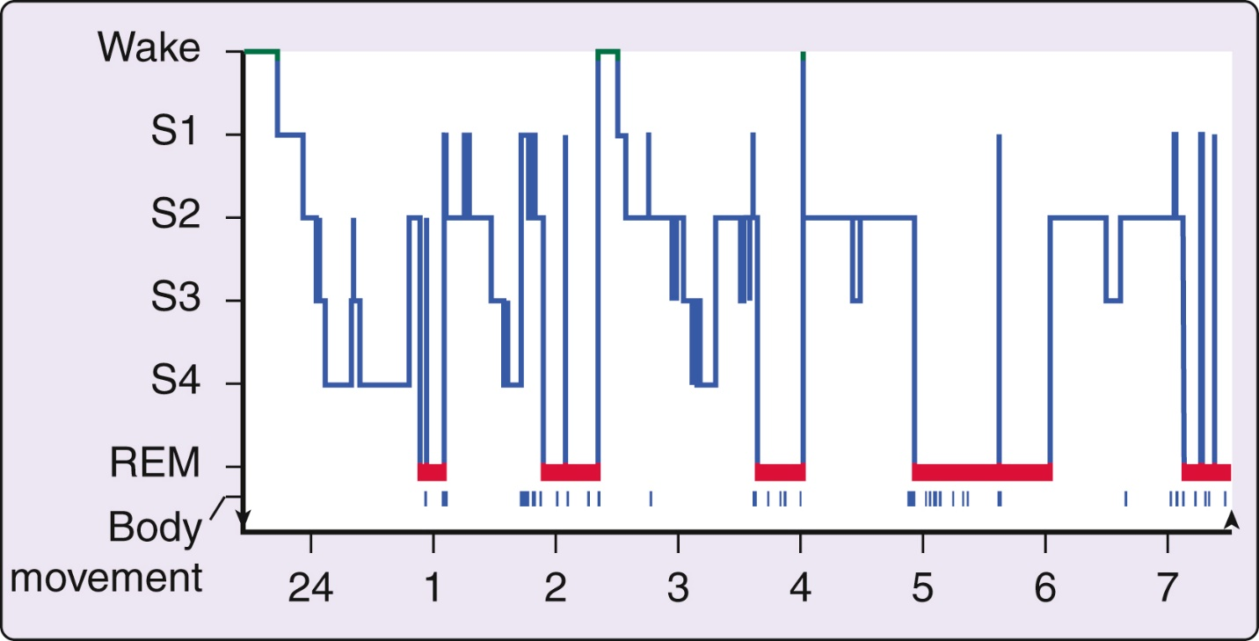

the first night of a laboratory sleep evaluation is commonly associated with more frequent arousals and a disruption of the normal distribution of sleep states, characterized chiefly by a delayed onset of REM sleep.36   
*36. Agnew HW, Webb WB, Williams RL. The first-night effect: an EEG study of sleep. psychophysiology. 1966;2:263–266*

Often this delay takes the form of skipping the first REM episode of the night. In other words, the NREM sleep stages progress in a normal fashion, but the first cycle ends with an episode of stage 1 or a brief arousal instead of the expected brief REM sleep episode. In addition, REM sleep episodes are often disrupted, and the total amount of REM sleep on the first night in the sleep laboratory is also usually reduced from the normal value.

Periodic limb movements, sleep apnea syndromes, musculoskeletal conditions, and so forth may be associated with tens to hundreds of arousals each night.

[https://www.**clinicalkey**.com/#!/browse/book/3-s2.0-C20201045178](https://www.clinicalkey.com/#!/browse/book/3-s2.0-C20201045178)

<https://www.sleepfoundation.org/parasomnias>

### RSWA

https://www.sciencedirect.com/science/article/pii/B9780323242882001033

Opsumering af rækeefølgende på PD og RBD, brain first vs Body fiste

Ideopadisk RBD, uden neuro degenerativ diagnose (Det er ikke en sydog

Pd uden RBD

pd med RBD

RSWA - REM sleep without atonia (RSWA) (spr casper med literaur, hvormange går videre)

RBD - Dream inactment, (udlevelsen af den drøm, intendede bevægelser)

Continium

RSWA - RBD - PD

Undgår patologiske, men mindre jeg vil konkretiserer hvorfor det er vigtigt at bremse tidligt. Det er nødvendigt med tilig dianostic

Hvad er de dianostice kriteriger, PET er nuværende ogderfor fungere det ikke som screning, men hvis vi kan dianosticerer RSWA, og bruge vores device til screning af dem, så er det fordelagtigt.

Idiopatisk RBD, ukendt årsag

316 patients with iRBD, a proxy-reported family history of presumed RBD was found in 13.8% of cases, compared with 4.8% of control subjects. [17] from https://www.sciencedirect.com/science/article/pii/B9780323242882001033

Sixty-four percent of bed partners report being assaulted, and many have been injured. 11,22. Injurious behaviors include punching, slapping, kicking, pulling of hair, and attempted strangulation. 6,11,24,22

The reported frequency of RBD in Parkinson disease ranges between 15% and 65%. 30,31,32,33,34

The REM Sleep Behavior Disorder Single-Question Screen (RBD1Q) poses a single “yes/no” question about dream enactment, providing 93.8% sensitivity and 87.2% specificity for RBD diagnosis in Parkinson disease in a large, multicenter validation study. [137]

Diagnostic criteria for RBD include the presence of RSWA (Figure 103-2) on polysomnography, sleep-related injurious or potentially injurious disruptive behaviors by history, and/or abnormal REM sleep behaviors during polysomnography, absence of epileptiform activity during REM sleep (unless RBD can be clearly distinguished from any concurrent REM sleep–related seizure disorder), and no better alternative explanation for the sleep disturbance. [132]

Polysomnographic RSWA manifests in submentalis, anterior tibialis, and arm leads of the electromyogram (EMG), especially flexor digitorum superficialis (FDS) and biceps brachii. 132,148,149,150 An expanded EMG montage, including the FDS, biceps, and abductor pollicis brevis muscles, has been shown to be most sensitive for identifying RSWA.149,150

The American Academy of Sleep Medicine has defined abnormal RSWA as the presence of five or more 3-second mini-epochs containing excessive measured phasic (transient) muscle activity within a single 30-second REM epoch. 132

RSWA without clinical dream enactment occurs frequently in Parkinson disease and other synucleinopathies, suggesting that additional lesions in other structures may be required to mediate full RBD. 31